Victor Li, Jenna Giordano, Santiago Vivar

Dr. Mao

Data Communications

12/4/2018

Group Project 3

To start this project, run the command “npm install”. Once every package has been set up, you can either run “npm start” or “npm run start-dev”. The first command is for production mode while the second is for development mode. Once you run this command you should see a message on the command line saying “listening on Port 9001”

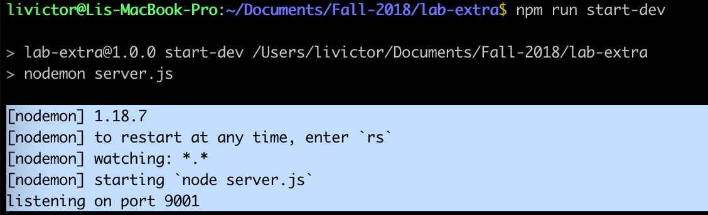

Once you are on port 9001, all you have to do is go through your localhost:

*http://localhost:9001/*

As soon as you access this URL, the server will catch that get request and send back the public file which contains the html, css, mp4, js, png file. Between the reception of the request and the response, the server will also display on the command line all of the files that were sent to the client: 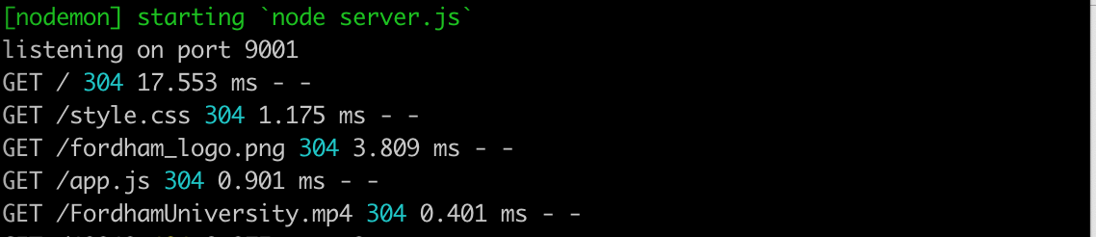

304 means that nothing got modified, it is not an error message. Error messages are 400+ and 500+. Now if you type in a path that is not recognizable, it will handle the error and make it a 404 status meaning that the page requested does not exist.



We also customized our message on the page for the user to understand that the page requested does not exist on the client side

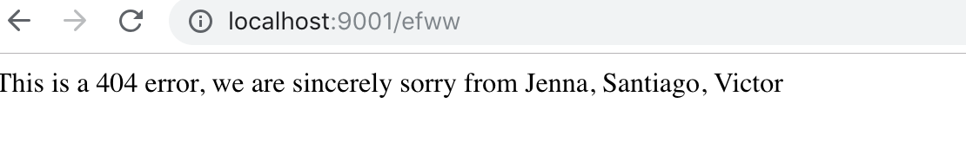

That is it! Thank you for reading this.